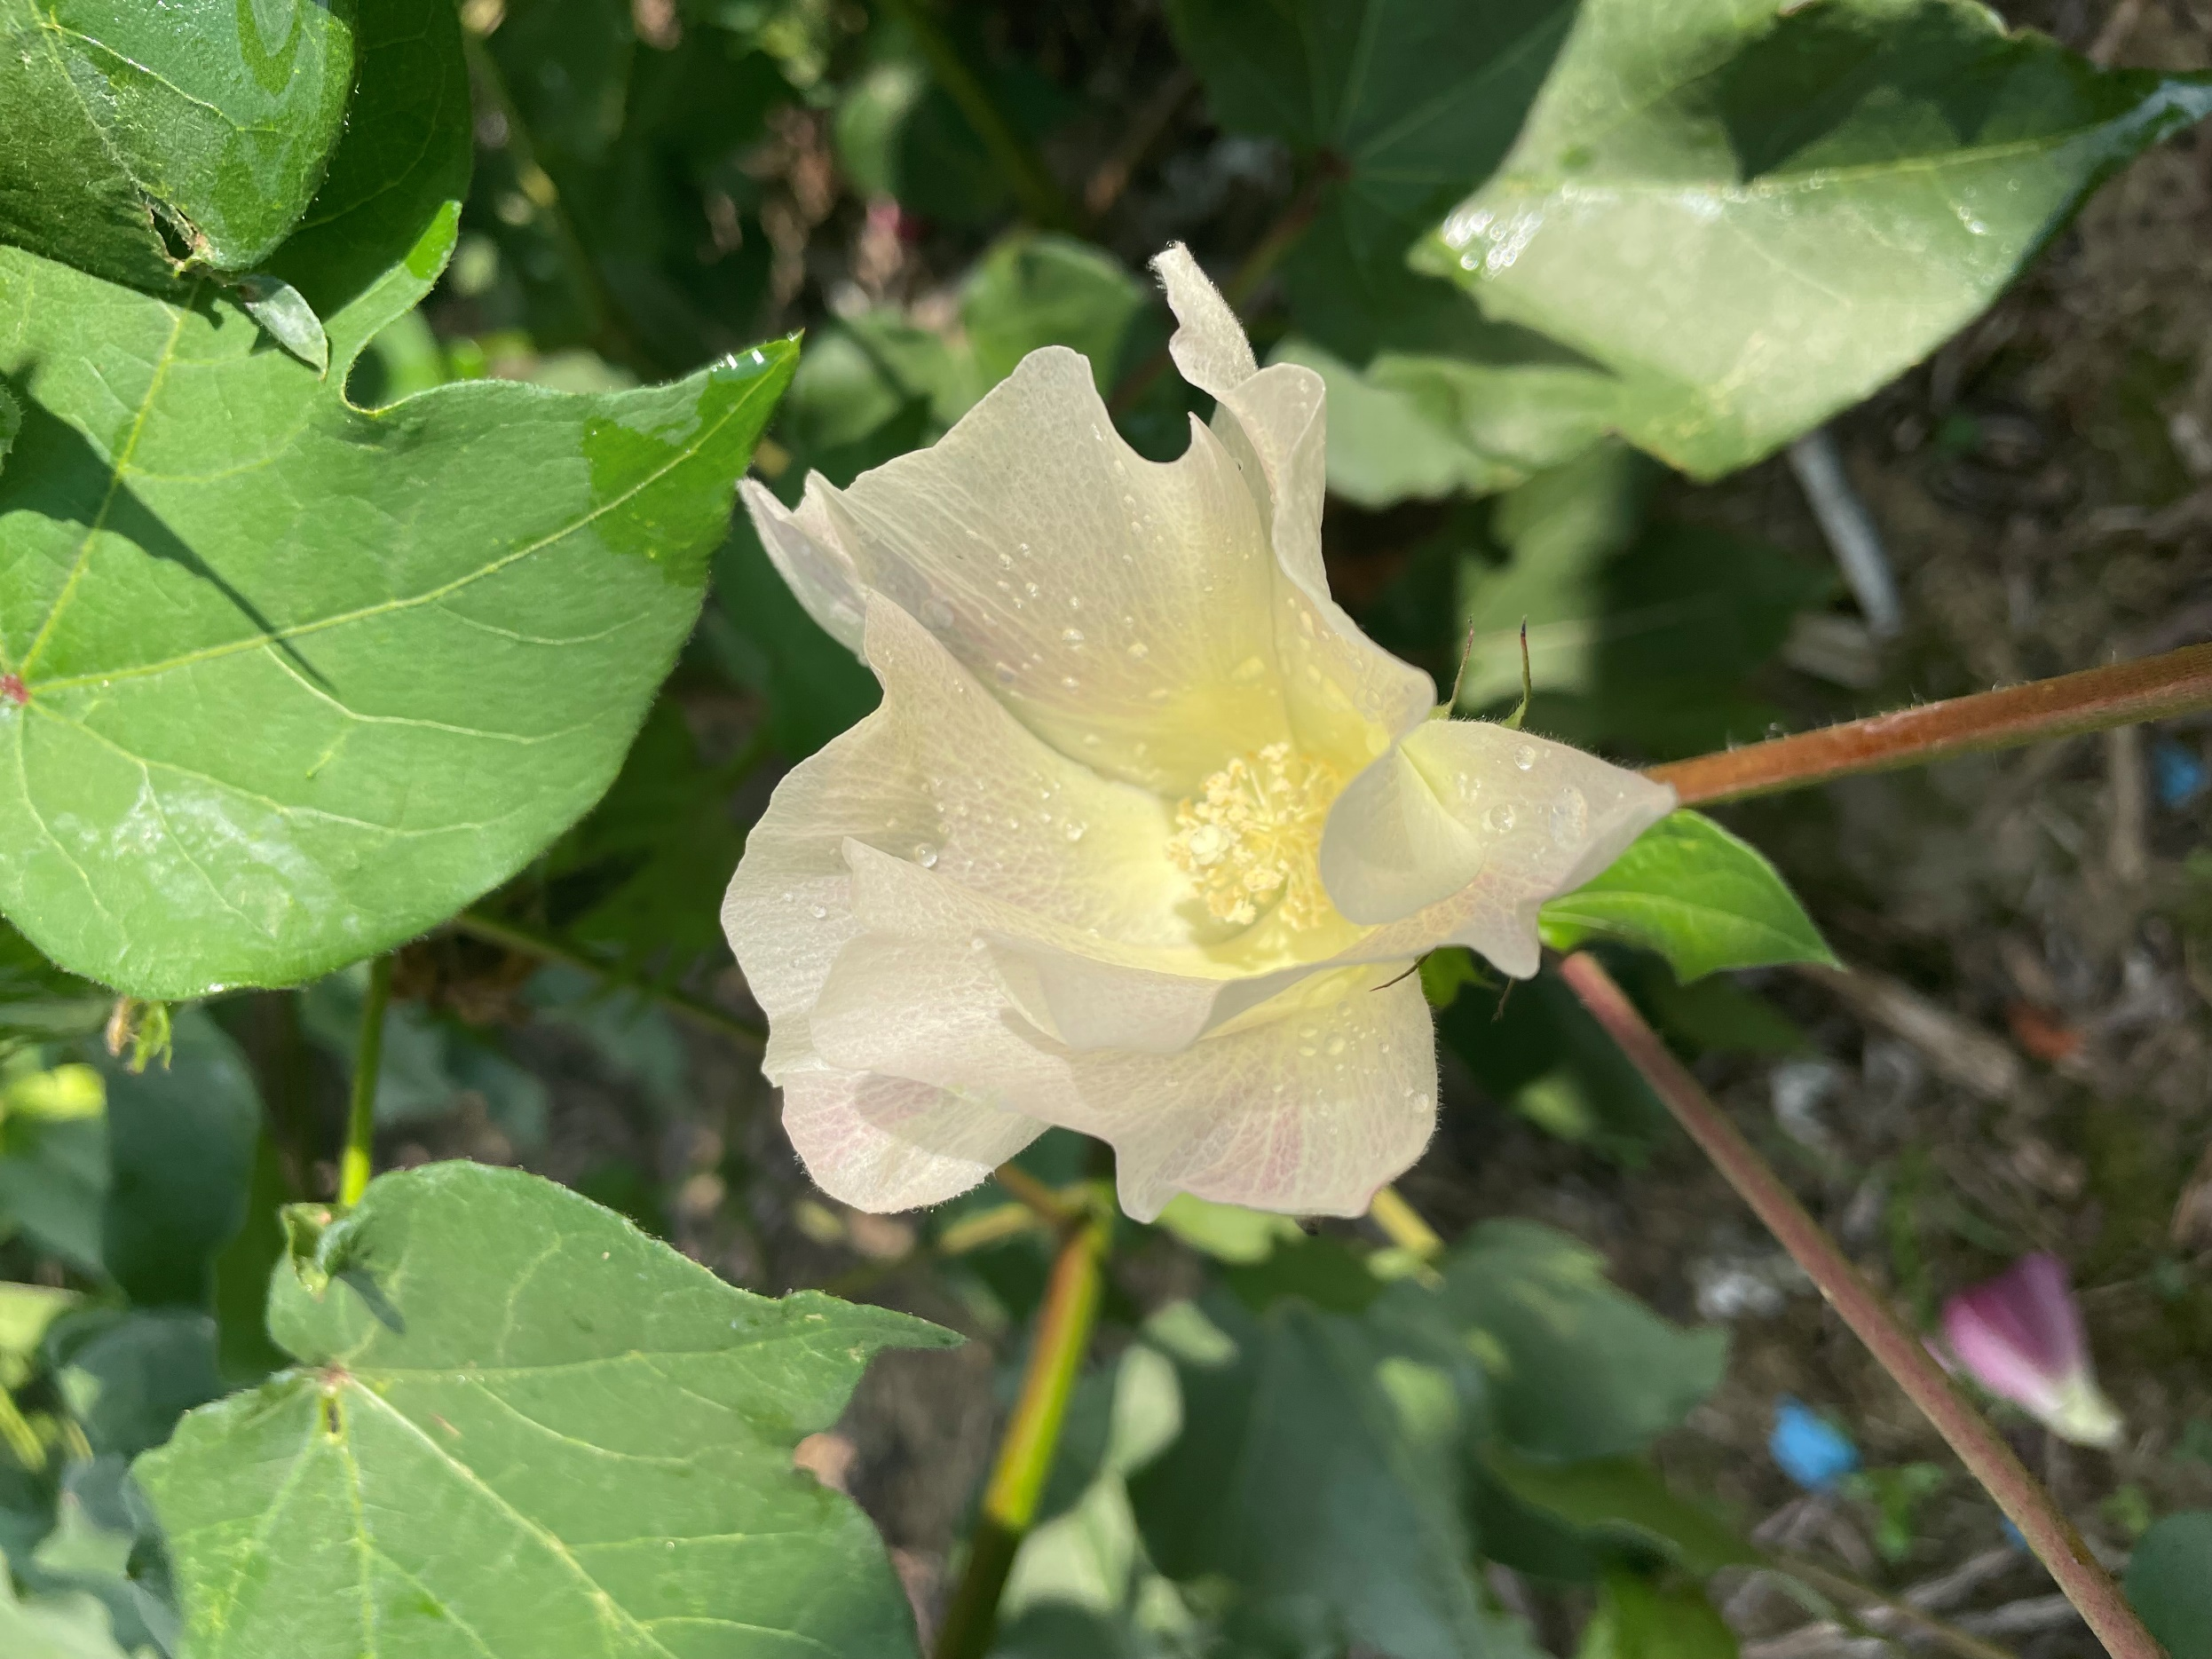



Cotton Tour

Wednesday, Sept 11, 2024
8AM-1PM
West Tennessee Research and Education Center
605 Airways Blvd Jackson, TN 38301
Lunch catered by Tulum

8:00AM
Arrive at WTREC
Mr. Hunter Goodman- Welcome and load tour wagons
8:15AM
Corner of Field 22
Dr. Nutifafa Adotey- Nitrogen and Potassium update
Dr. Heather Kelly- Seed treatment and row spacing
Dr. Sebe Brown- ThryvOn and B3XF sprayed and unsprayed
9:15AM
South end of grassed middle, Sub-Surface Drip
Dr. Jake McNeal, Mr. Drew Denton- Soybean and Corn Research overview/update
9:45 AM
Behind farm shop
Dr. Tyson Raper- Defoliation Demo, biologicals, deer
10:05 AM
Field 4 and Field 7
Dr. Heather Kelly- Foliar diseases in TN
Dr. Tyson Raper- Variety testing
Dr. Sebe Brown and Nathan Arey- ThryvOn Efficacy on Stink Bugs and Clouded Plant Bugs
11:00 AM
Weed Tour Parking Lot
Dr. Larry Steckel- Weed control update
11:30 AM
Field 4 and Field 7
Dr. Avat Shekoofa- Cotton water dynamics and cover crops
12:00PM Lunch

