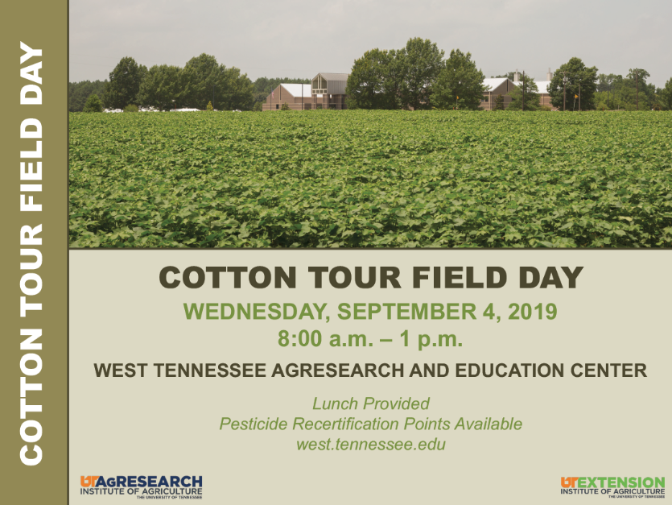

8:40 Corner of Field 23
Heather Kelly
Disease update (20 min)
Larry Steckel
Cotton weed control update (20 min)

9:25 Subsurface Drip
Tyler Sandlin
Defoliation comments for 2019; determining products, rates and timings (20 min)
Tyson Raper
Update on 2019 variety testing (10 min)
Savana Denton
Cover crop research overview (10 min)

10:15 Avat’s cotton out back
Avat Shekoofa
Cotton irrigation scheduling and variety selection (20 min)
Dawson Kerns and Scott Stewart
Bt technology, worm control (15 min)

10:50 Plant Bug Block
Sandy Steckel and Scott Stewart
Plant Bug (15 min)

11:10 Room A, Main Building
Aaron Smith
Cotton market outlook (20 min)
Lori Duncan
US Trust Protocol (20 min)

