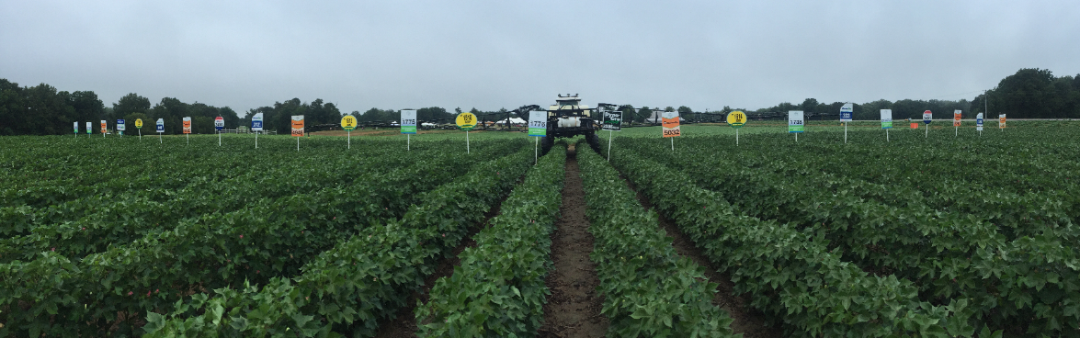
2017 Cotton Focus

Thursday, February 9, 2017
8:30 AM-1:00 PM
West Tennessee Research and Education Center
605 Airways Blvd
Jackson, TN 38301

8:30 AM REGISTRATION
8:55 AM
Opening Remarks
Mr. Richard Buntin, Crockett County Extension Director
9:00 AM
2016 Variety Performance, 2017 Variety Selection
Dr. Tyson Raper, Cotton Specialist; University of Tennessee
9:30 AM
Target Spot: Potential Impacts on Tennessee Cotton
Dr. Heather Kelly, Field Crops Pathologist; University of Tennessee
10:00 AM
Cotton Market Outlook and Risk Management Decisions in 2017
Dr. Aaron Smith, Crop Marketing Specialist, University of Tennessee
10:30 AM
General Update on Insect Control: Thrips, Plant Bugs and New Traits
Dr. Scott Stewart, Extension Entomologist, University of Tennessee
11:00 AM
Injection Technologies for Newly Labeled Chemistries
Mr. Patrick Wright, Account Manager, Raven Industries
Mrs. Elizabeth Pugh Lague, Senior Business Representative, BASF
11:20 AM
Weed Control Update
Dr. Garret Montgomery, Weed Science Post-doc; University of Tennessee

12:00 PM LUNCH

