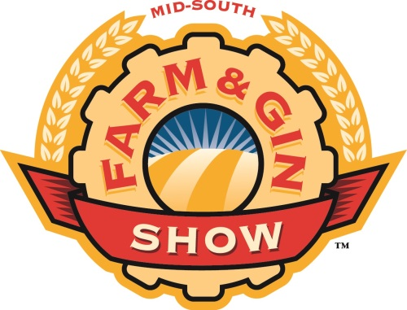
874 Cotton Gin Place Memphis, TN 38106 901.947.3104

2015 Mid-South Farm & Gin Show
Welcomes new exhibitors, features educational seminars

The 63rd annual Mid-South Farm & Gin Show is scheduled for February 27- 28, 2015 at the Cook Convention Center, Memphis, TN. Those two days, more than 400 exhibitors from over 40 states will be on hand showcasing the latest technology and innovation available in agriculture.
“The Mid-South Farm & Gin Show is a very popular event for companies who serve farmers and ranchers and others in agriculture,” says Tim Price, show manager. “The rapid pace of change in agriculture drive many of the innovative products and services on display at the show. Companies listen to the decision-makers who attend this show each year and develop the products and services they need to continue to do what they do best – produce crops. Farmers attending the Mid-South Farm and Gin Show will have the opportunity to get a firsthand look at what’s new in the industry -- new technology, new products, and other new developments in agriculture.”
While some of the more than 400 exhibitors at this year’s are returning exhibitors - some going back to the show’s beginning 63 years ago – many new exhibitors will be part of the show for the first time. “We definitely appreciate the commitment our long-standing exhibitors have to the industry and to interacting with the attendees at this show,” Price notes. “We look forward to seeing them each year. At the same time, we are thrilled so many new and diverse companies want to be part of this show.”
In addition to the three full floors of exhibits and exhibits outside the Convention Center, there will also be educational opportunities such as Ag Update sessions and special seminars.
Ag Update Seminars are scheduled for Friday, February 27 and Saturday, February 28, beginning at 8:30 a.m. in the Lobby Meeting Room. Attendees can expect to hear from Sledge Taylor, incoming chairman of the Cotton Council, Carl Brothers, Riceland Foods, and Joe Nicosia, of Louis Dreyfus. Richard Brock, of Brock Associates will headline the Saturday, February 28, Ag Update seminar, providing his unique perspective on grain marketing, as well as a market outlook.
Plans are also being finalized for the Mid-South Ag Forum, a seminar focusing on successful technology adoption from research to the farm. This seminar, scheduled for 1:30 p.m. on Friday, February 27, will feature researchers and farmers who will explore irrigation innovations and technology adoption on the farm. The Forum will held on the Mezzanine Level of the Convention Center.

A special Rice Seminar – What the U.S. Rice Farmer Needs to Know to Prosper – is set for Saturday, February 28, at 1:30 p.m. on the Mezzanine Level of the Convention Center. Milo Hamilton, Co-founder and senior ag economist of First Grain, Inc., is the featured speaker.

All of this information and more is available on the updated mobile app, which can be downloaded from iTunes or from the Android app store. The app features show schedules and updates, speaker biographies, and maps and exhibitor information, all designed to enhance the attendee experience. The Mid-South Farm and Gin Show app has proven to be very popular. Regular updates to information will be made to the app during the two-day show.

Price encourages people to pre-register for the show. “We’re again using online registration to ease the process of on-site printing of name badges. Go to the Farm and Gin Show website (www.farmandginshow.com) click on the “attendee registration” button, complete the form and print out the confirmation form. Bring that form with you to the show and staff on-site will help you complete the process and get your name badge so you can quickly get onto the show floor,” Price says. Anyone who pre-registers for the show by February 16 will be entered into a drawing for $1,000. The winner will be notified on February 17, and must collect the prize at the Registration Booth at the Farm and Gin Show.

Show hours are Friday, February 27, from 9:00 a.m. to 5:00 p.m. and Saturday, February 28, from 9:00 a.m. to 4:30 p.m. More information is available at www.farmandginshow.com

